M E M O R A N D U M

TO: Water Quality Standards Workgroup

FROM: Chris Bittner

DATE: March 15, 2022

SUBJECT: Proposed extension of existing site-specific ammonia water quality criteria for Jordan River to lower Jordan River and State Canal

Introduction and site investigations.

In 2019, the Utah Water Quality Board adopted site-specific ammonia water quality criteria for the protection of aquatic life for the Jordan River, Salt Lake County, from 900 South to the confluence with Mill Creek. The basis for the criteria was that unionid mussels were not aquatic life residents. A critical first step when evaluating if unionid mussels are residents is establishing that they are not currently present.

In 2019, the Wasatch Front Water Quality Council conducted additional unionid mussel surveys on the Jordan River downstream of 700 North Street and in the State Canal. In 2021, surveys were conducted on the Jordan River between 700 North Street and 900 South Street. Combined with the surveys conducted in 2017 on the Jordan River between Mill Creek and Little Cottonwood Creek, the Jordan River has been surveyed from Little Cottonwood Creek to Farmington Bay, Great Salt Lake. Figure 1 provides an overview of the study area. The surveys are documented in the following reports:

- Native Unionoida Surveys, Distribution, and Metapopulation Dynamics in the
Jordan River-Utah Lake Drainage, UT, Oreohelix Ecological, May 26, 2017
- Lower Jordan River Mollusk Survey as it Relates to South Davis Sewer District South Plant Effluent, January 2, 2020, Oreohelix Ecological (DWQ-2020-007383);
- State Canal Mollusk Survey as it relates to South Davis Sewer District South Plant Effluent, January 3, 2020, Oreohelix Ecological (DWQ-2020-012604);
- Jordan River Native Mussel Surveys, April 9, 2021, Oreohelix Ecological (DWQ-2021-010122).

In summary, the surveys were conducted by excavating the substrate with a shovel in wadable sections and hand-operated dredges in deeper water. The substrate samples were then sieved and examined for the presence of mollusks. The specific locations surveyed are shown on Figures 2 through 5. Aside from a few Anodonta shell fragments, no evidence of unionid mussels was observed.

The affected assessment units and their water quality support status can be mapped at https://deq.utah.gov/water-quality/2022-integrated-report. The lower Jordan River portion includes Jordan River-1, Jordan River-2, and a small segment of Jordan River-3 from North Temple to 900 South. The segment between Mill Creek and Little Cottonwood Creek is part of Jordan River-4 Assessment Unit. Water quality impairments include:
- Jordan River-1, dissolved oxygen and benthic macroinvertebrates;
- Jordan River-2, dissolved oxygen, benthic macroinvertebrates, and E. coli;
- Jordan River-3, dissolved oxygen, benthic macroinvertebrates, total phosphorus, and E. coli;
- Jordan River-4, benthic macroinvertebrates, E. coli, and total dissolved solids.
- State Canal, ammonia, dissolved oxygen, and total dissolved solids.
Note that the lower Jordan River and State Canal have site-specific criteria for dissolved oxygen in Table 2.14.5, R317-2-14 but still remain impaired.

Are unionid mussels residents?

Numeric criteria protect the designated uses. The criteria are derived to protect the aquatic life residents. In 2013, the U.S. Environmental Protection Agency (EPA) updated the recommendations for ammonia criteria. These criteria are less stringent if unionid mussels are not residents. Per the EPA, residents:

- Are usually present at the site.
- Are present at the site only seasonally due to migration;
- Are present at the site intermittently because they periodically return to or extend their ranges into the site;
- Were present at the site in the past, are not currently present at the site due to degraded conditions, but are expected to return to the site when conditions improve;
- Are present in nearby bodies of water, are not currently present at the site due to degraded conditions, but are expected to be present at the site when conditions improve.

Residents don’t include organisms that were once present at the site, but cannot exist at the site now due to permanent (physical) alterations of the habitat or other conditions that are not likely to change within reasonable planning horizons.

These resident definitions with regards to unionid mussels were evaluated in detail to support the 2019 site-specific criteria (see Site-specific criteria based on recalculated aquatic life water quality criteria for ammonia for a segment of Mill Creek and the Jordan River, Salt Lake County, Utah (DWQ-2018-013091)). The conclusions from this evaluation were:

- Unionid mussels historically were present upstream in the Jordan and Utah Lake, tributaries to Jordan River and were also likely present at the Site.

- Unionid mussels are not currently present at the Site or in the nearby waters that were surveyed because of degraded conditions. Not all nearby waters were surveyed.

- Non-pulmonate snails are present, or were recently present at the Site and are residents.

- The Jordan River is physically, biologically and chemically degraded at the Site. Efforts to restore the Jordan River are ongoing but are unlikely to be sufficient to support the potential reintroduction of unionid mussels within the reasonable planning horizon of the next 30 years, if ever.

These same conclusions are also applicable to:
- The Jordan River, from Farmington Bay to 900 South;
- The State Canal, from Farmington Bay to the confluence with the Jordan River, and;
- The Jordan River, from the confluence of Mill Creek to Little Cottonwood Creek.

DWQ recommends that the existing site-specific criteria in Footnote 9, Table 2.14.2 in R317-2-14 be modified to include the lower Jordan River, the Jordan River from Mill Creek upstream to the confluence with Little Cottonwood Creek, and the State Canal. The proposed revised rule follows with the deletions shown in red strikeout font and the proposed additions shown in green underlined font. Note that a typographical error in the current rule (09.405 to 0.9405) is also corrected.

Proposed rule language
.
(9a) The thirty-day average concentration of total ammonia
nitrogen (in mg/l as N) does not exceed, more than once every
three years on the average, the chronic criterion calculated
using the following equations.
Fish Early Life Stages are Present:
mg/l as N (Chronic) = ((0.0577/(1+10^{7.688-pH})) + (2.487/(1+
10^{pH-7.688}))) * MIN (2.85, 1.45*10^{0.028*(25-T)})
Fish Early Life Stages are Absent:
mg/1 as N (Chronic) = ((0.0577/(1+10^{7.688-pH})) + (2.487/
(1+10^{pH-7.688}))) * 1.45*10^{0.028*} ^{(25-MAX(T,7))})
Mill Creek (Salt Lake County) from confluence with Jordan River
to Interstate 15, Jordan River from Farmington Bay 900 South Street to confluence
with Mill Creek, Surplus Canal from 900 South Street to diversion from the Jordan River, State Canal from Farmington Bay to confluence with the Jordan River, Fish Early Life Stages are Present:
mg/l as N (Chronic) = 0.9405 * ((0.0278/(1+10^{7.688-pH})) + ((1.1994/(1+10^{pH-7.688}))) * MIN(6.920,(7.547*10^{0.028*(20-T)})))
Mill Creek (Salt Lake County) from confluence with Jordan River
to Interstate 15, Jordan River from Farmington Bay 900 South Street to confluence
with Mill Creek, Surplus Canal from 900 South Street to diversion
from the Jordan River, State Canal from Farmington Bay to confluence with the Jordan River,Fish Early Life Stages are Absent:
mg/L as N (chronic) = 0.9405 09.405 * (((0.0278/(1+10^{7.688-pH})) +
(1.1994/(1+10^{pH-7.688}))) * (7.547*10^{0.028*(20-MAX (T,7))})
(9b) The one-hour average concentration of total ammonia
nitrogen (in mg/l as N) does not exceed, more than once every
three years on the average the acute criterion calculated
using the following equations.
Class 3A:
mg/l as N (Acute) = (0.275/(1+10^{7.204-pH})) + (39.0/1+10^{pH-7.204}))
Class 3B, 3C, 3D:
mg/l as N (Acute) = 0.411/(1+10^{7.204-pH})) + (58.4/(1+10^{pH-7.204}))
Mill Creek (Salt Lake County) from confluence with Jordan River
to Interstate 15, Jordan River from Farmington Bay 900 South Street to confluence
with Mill Creek, Surplus Canal from 900 South Street to diversion
from the Jordan River, State Canal from Farmington Bay to confluence with the Jordan River:
mg/l as N (Acute) = 0.729 * (((0.0114/(1+10^{7.204-pH}))+(1.6181/
(1+10^{pH-7.204}))) * MIN(51.93,(62.15*10^{0.036*(20-T)}))
In addition, the highest four-day average within the 30-day
period should not exceed 2.5 times the chronic criterion.
The "Fish Early Life Stages are Present" 30-day average total
ammonia criterion will be applied by default unless it is
determined by the Director, on a site-specific basis, that it
is appropriate to apply the "Fish Early Life Stages are
Absent" 30-day average criterion for all or some portion of
the year. At a minimum, the "Fish Early Life Stages are
Present" criterion will apply from the beginning of spawning
through the end of the early life stages. Early life stages
include the pre-hatch embryonic stage, the post-hatch free
embryo or yolk-sac fry stage, and the larval stage for the
species of fish expected to occur at the site. The Director
will consult with the Division of Wildlife Resources in making
such determinations. The Division will maintain information
regarding the waterbodies and time periods where application
of the "Early Life Stages are Absent" criterion is determined
to be appropriate.

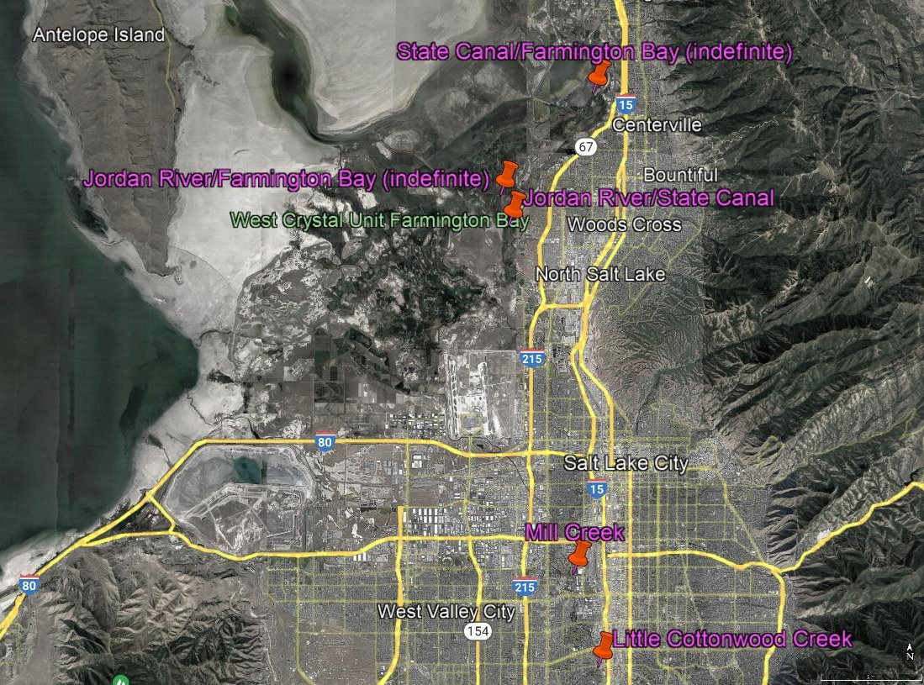
Figure 1. Overview Google Earth® map of site. From the top and moving south, red pins show approximate boundary of State Canal and Farmington Bay, approximate boundary of Jordan River and Farmington Bay confluence of Jordan River and Little Cottonwood Creek, confluence of Jordan River and State Canal, , and.

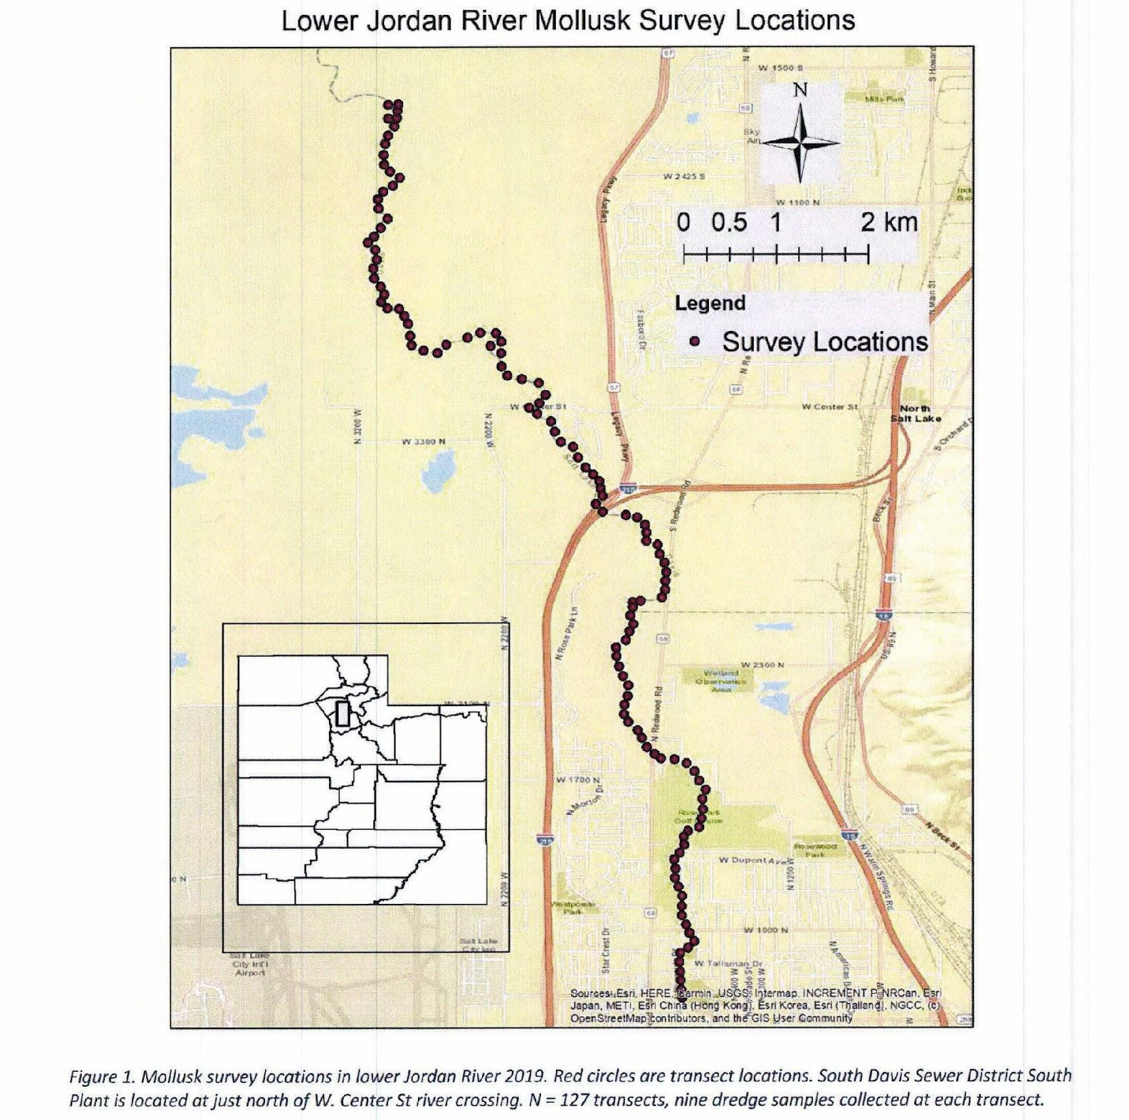
Figure 2. Mollusk survey locations for Assessment Units Jordan River-1 and Jordan River-2. Source: Lower Jordan River Mollusk Survey as it Relates to South Davis Sewer District South Plant Effluent, January 2, 2020, Oreohelix Ecological (DWQ-2020-007383)

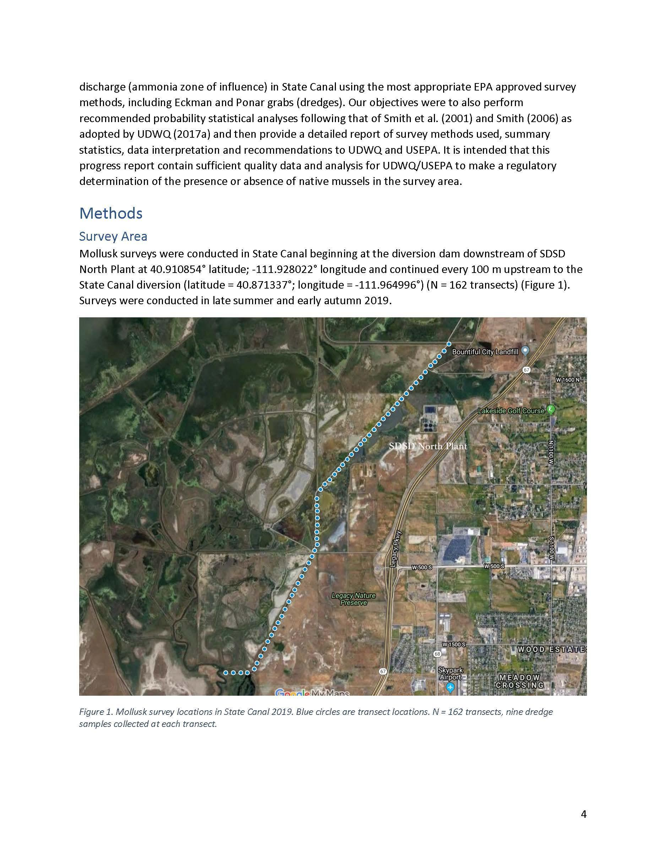
Figure 3. Mollusk survey locations for State Canal. Source: State Canal Mollusk Survey as it relates to South Davis Sewer District South Plant Effluent, January 3, 2020, Oreohelix Ecological (DWQ-2020-012604)

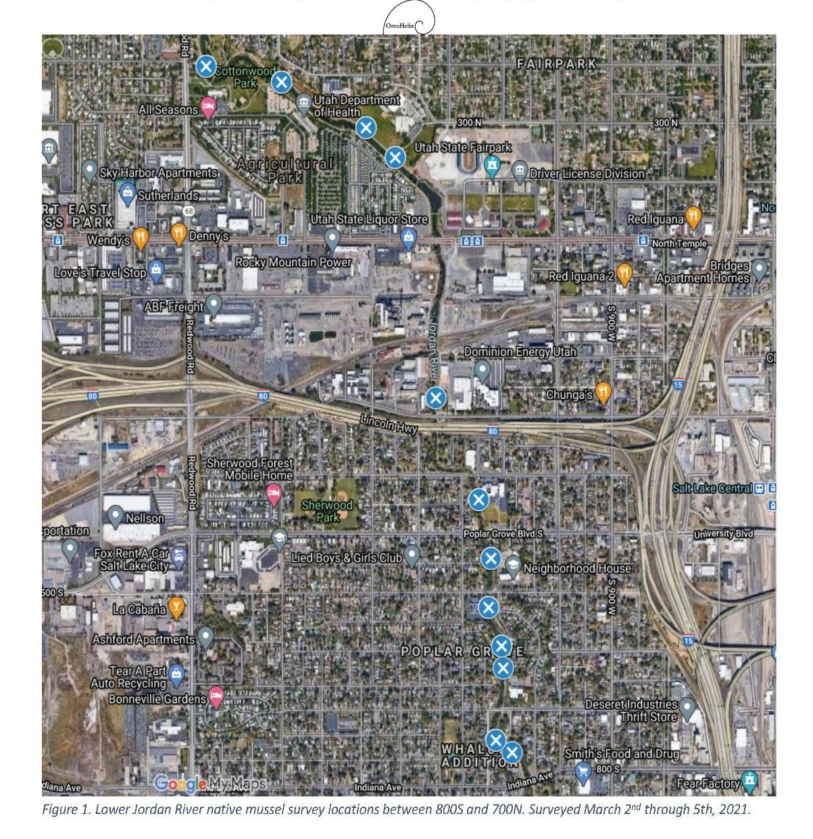
Figure 4. Mollusk survey locations in Assessment Units Jordan River-2 and Jordan River-3. Source: Jordan River Native Mussel Surveys, April 9, 2021 Oreohelix Ecological (DWQ-2021-010122)
.
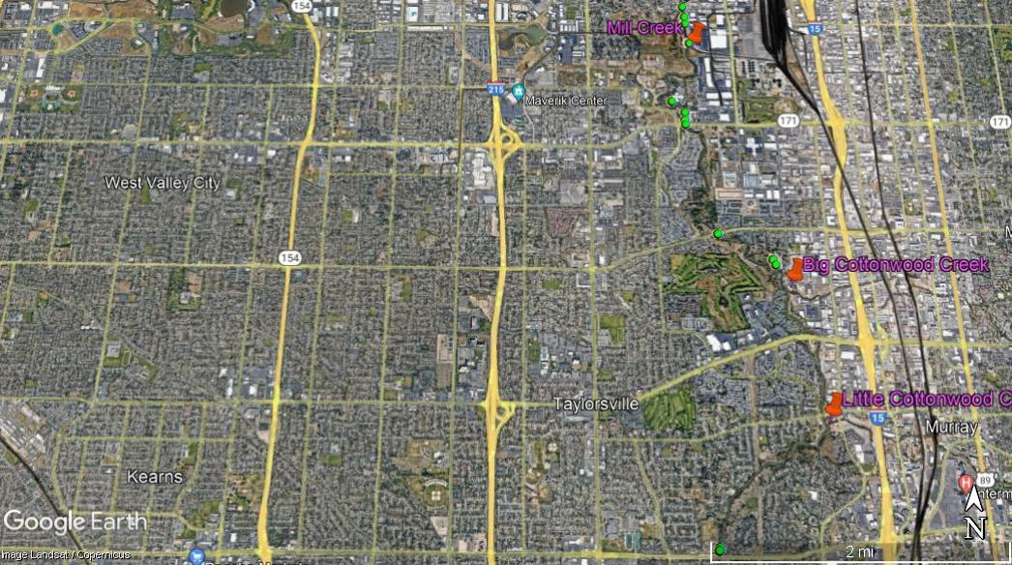
Figure 5. Mollusk survey locations (green circles) in Jordan River-4. (data from Native Unionoida Surveys, Distribution, and Metapopulation Dynamics in the Jordan River-Utah Lake Drainage, UT, Oreohelix Ecological, May 26, 2017)

